Birds of a Feather Don’t Flock Together:

China’s Foreign Aid Targeting in Relation to Governance Style

Edgar Agunias A69046387
GPCO 454 - Quantitative Methods II
Independent Analysis Project
Professor Ravanilla
March 11th 2026



Acknowledgements

Table of Contents
Birds of a Feather Don’t Flock Together: 1
China’s Foreign Aid Targeting in Relation to Governance Style 1
Acknowledgements 2
Table of Contents 3
Memo 4
Introduction 4
Theory and Hypothesis: 4
Data Description: 4
Methodology and Findings: 6
Limitations and Conclusion: 6

Memo
Date: March 11th 2026
To: Marco Rubio, Secretary of State
From: Edgar Agunias
Regarding: China’ Aid Targeting Strategy

Introduction
With a large US pull back on foreign aid contributions in the UN and otherwise, many in the international community look to China to fill this gap. Many see it logical for China to fill this gap in influence, however traditionally China has been selective in where it allocates its ODA. This research was designed to answer if China’s foreign aid is tightly correlated to more authoritarian governments. China’s aid allocation differs from the US which is typically concentrated in the UN, while China’s is more direct and thus bilateral. Chinas development finance and belt and road initiative is seen more politically motivated in the West, when compared to Western aid. Therefor the purpose of this research is to see if China’s Aid disbursement method has preference to other authoritarian governments. After extensive quantitative research using a country level cross sectional regression analysis, there is a positive association. However, after economic and demographic controls are accounted for in the full sample, the countries government does not have a statistically significant relationship with how much aid a country receives. At the same time, among countries that did receive positive Chinese aid, a one point increase in autocracy score is associated with about 2.95 times higher mean annual aid. Suggesting China may have different criterion for aid disbursement if aid is being given.

Theory and Hypothesis:
Our causal research question is: Do more autocratic regimes receive more funding from China on average?
Null Hypothesis: Autocratic Regimes do not differ in average aid received when compared to Democratic ones.
Alternative Hypothesis: Autocratic regimes receive more aid on average when compared to Democratic ones.
$$H_{0}: μ_{Autocratic}=μ_{Democratic} H_{a}: μ_{Autocratic}>μ_{Democratic}$$

Data Description:
Using the Our World in Data (OWID) data set for classification of autocratic governments and the Chinese Global Development Finance Data set for levels of foreign Aid provided by China to run my cross sectional regression. Our final data set collapsed the years of 2013 to 2021 into country averages, making the unit of analysis the country. The bivariate model utilized 174 countries, the controls model utilized 135 countries, and the positive aid only model utilized 92 countries. Our reconfigured OWID data set classified autocratic governments on a scale from 0 to 3, with 0 being electoral democracies and 3 being closed autocracies. China itself is classified as a closed autocracy. In the graph below we can see that even when adjusting aid as a logarithm of its mean annual value so that extremely large dollar donations do not dominate the graph, more autocratic regimes received more aid from China. We also see that after a regression analysis there is a positive relationship between autocracy levels and level of aid provided in the bivariate model, though in the full controls model this relationship loses statistical significance.
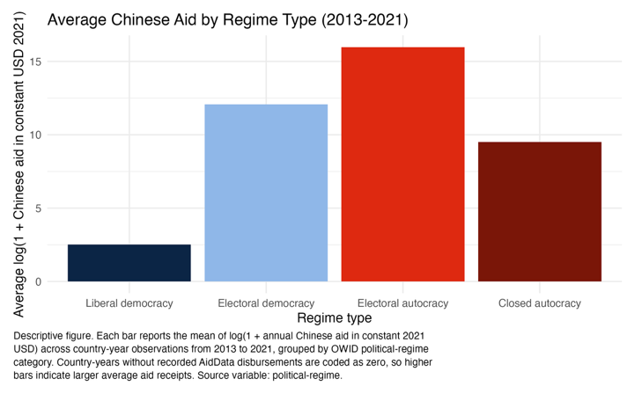 | 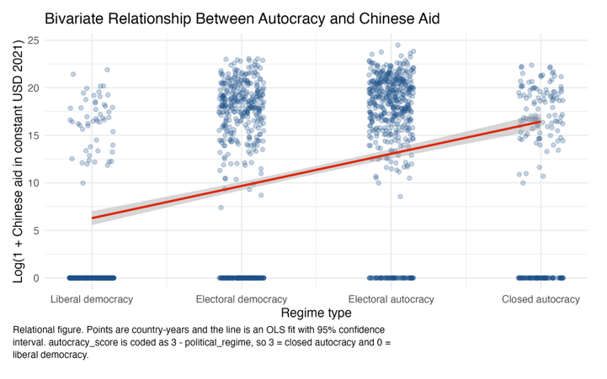

Chinese Aid and Regime Type (Country-Level Cross-Section)
 | Dependent variable:
 | Log(1 + mean annual Chinese aid in constant USD 2021)
 | Bivariate | Controls | Controls, positive-aid only
 | (1) | (2) | (3)
Autocracy score | 4.186*** | 0.948 | 1.083***
 | (0.769) | (1.171) | (0.397)
Log GDP per capita |  | -2.591*** | 0.812***
 |  | (0.960) | (0.276)
Corruption Perceptions Index |  | -0.207*** | -0.009
 |  | (0.061) | (0.026)
Extreme poverty share |  | -0.111** | 0.022
 |  | (0.046) | (0.013)
Gini index |  | 29.888*** | 1.008
 |  | (8.620) | (3.314)
Constant | 7.642*** | 35.808*** | 9.717***
 | (1.165) | (9.093) | (2.533)
Unit of analysis | Country | Country | Country
Years collapsed | 2013-2021 mean | 2013-2021 mean | 2013-2021 mean
Sample | All countries | All countries | Aid recipients only
Standard errors | HC1 | HC1 | HC1
Observations | 174 | 135 | 92
R2 | 0.202 | 0.594 | 0.165
Adjusted R2 | 0.197 | 0.578 | 0.117
Note: | *p<0.1; **p<0.05; ***p<0.01

Methodology and Findings:
Our regression structure is a simple cross sectional linear regression. After controlling for variables this positive relationship loses statistical significance in the full sample. For example, GDP per capita to control for development levels of economies and their correlated effects on governmental structures. Corruption index was used to control for government quality, as perhaps China utilizes it to assess efficacy of their aid which may be lost to corruption. Extreme poverty share acts as a control for aid need in a country. As countries with higher percentage of the population living in extreme poverty are in greater need of aid. Gini coefficient controlled for level of inequality within a country receiving aid. Finally, because the data was collapsed into country averages from 2013 to 2021, the model compares countries on their mean aid levels rather than controlling for country specific and year specific changes in aid disbursement. All this to isolate any correlational relationship between style of government and the corresponding level of Chinese aid. We chose to make a distinction between countries who received Chinese aid and those that did not to prevent selection bias within our sample.
After all controls were taken into account in the full sample, it is clear that there is no statistically relevant correlational relationship between level of autocracy and amount of Chinese aid. However, among countries that did receive aid, the autocracy score remains statistically significant, and a one point increase in autocracy score is associated with about 2.95 times higher mean annual aid. These findings show that within the full sample China does not appear to allocate aid differently by regime type, but among recipient countries autocracy still appears to matter.

Limitations and Conclusion:
Some limitations of research were that GDP of countries could not be taken into account as only GDP per Capita was provided within the data set. This could introduce a bias for larger populations or economies which China may be more inclined to provide aid or shy away from providing aid. Another limitation is that by collapsing the data into a country level cross section, year to year variation is no longer captured. The full controls model also loses observations because of missing control variables, and some country cases appear to have stronger influence on the estimates than others. Therefore, while the full sample does not show a statistically significant relationship between autocracy and Chinese aid, the positive aid model indicates that if a country is more autocratic and has received aid at all that on average their mean aid increases by 2.95 times all things remaining constant.

